

Entry Form
People Development

Ensure you read and understand the criteria and guidelines before completing this form. Please remember that:

- Information above the specified word limits will not be taken into consideration.
- Charts and photos should be embedded in the word document where possible (captions are not taken as part of the
word count). Total submission length - maximum 15 pages.
- Appendices will not be reviewed as part of the submission.

Category Description: People Development

People are our greatest asset and this award recognises organisations that have really captured the full value of their human resource. Agents for change, those who proactively cascade education throughout their team, develop highly motivated movers and shakers, can make a significant impact on the future of the construction industry.
Judges are looking for an organisation that is leading edge in the way they develop their existing team and attract new entrants into the industry. Exemplary people developers will be able show judges how they:
- Invest in training and upskilling their workforce.
- Encourage new talent and entrants, possibly working in collaboration with other organisations.
- Encourage their employees and supply chain to be more aware of local communities, the environment and the image of the industry.
- Put equal opportunity and diversity in the mix for their development planning.
- Can evidence a development strategy with monitoring and measurement of achievement and effect.

People Development

Entry Form

SECTION 1
Entry name  (Please keep this concise)  This name will be etched on the award if successful |  | Manchester Smart Motorways - Leaving a Lasting Legacy
Applicant’s contact details | Name | Lucy Hingley
 | Organisation | Manchester Smart Motorways (MSM)
 | E-mail | Lucy.hingley@manchestersmartmotorways.com
 | Telephone | 07933 685105
 | Address | Barton Hall Industrial Estate, Hardy Street, Eccles, Greater Manchester
 |  | Postcode: M30 7NB

SECTION 2: Your submission
Background  Describe the circumstances or challenges faced in relation to this entry.  (maximum 250 words) | Manchester Smart Motorways (MSM) is the largest smart motorway currently being constructed in the UK and the only project that is being delivered collaboratively by all of the four smart motorway framework contractors: Balfour Beatty, Carillion, Costain and BAM/Morgan JV. Nearly 400 people are currently employed on the project, which sees technology based upgrades between junction 8 of the M60 and junction 20 of the M62.  One quarter of the Manchester Smart Motorways (MSM) project runs through the district of Salford, which is in the highest ten per cent of the most socially deprived areas in England. Colleges in the local area face numerous obstacles when engaging young learners and feel the strain of under-funding in the local community.  The MSM people development and community needs strategy has been designed specifically to help support and improve ‘hard to reach groups’ in inner city areas that are socially deprived in Greater Manchester.  The project’s Skills Coordinator has developed an ongoing working relationship with Salford Job Centre and Search Recruitment, securing the recruitment of several long term unemployed members of staff and providing work experience for students who were previously disengaged with their college studies and offenders going through rehabilitation.  The project has achieved over and above all of its key performance targets for its first target year creating, an environment that has allowed young professionals, the unemployed and minority groups to realise their full potential and develop key skills.
How do you invest in training and upskilling your workforce?  (maximum 250 words) | MSM has recruited a Project Skills Coordinator with a wealth of local experience. Through the Skills Coordinator’s expertise, MSM has invested in training and upskilling by developing several initiatives, many of which are unique to the project and the Highways Sector.  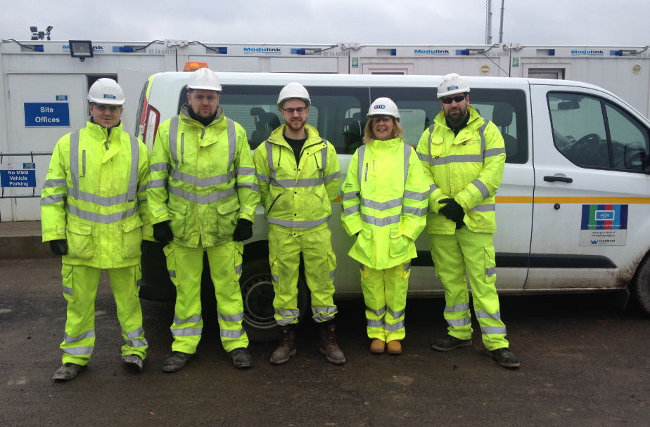  To date, 7 apprentices have been employed through a new route called the Higher Apprenticeship. This framework is a more advanced qualification than previous routes enabling them to gain an additional NVQ level 5 and shortening the period of study. MSM is the first highways project in the North West to introduce this apprenticeship, which is half the cost of the original HND route. Such savings has allowed MSM to further invest in training and development.  All young professionals on MSM are given the opportunity to work towards becoming a member of the Institute of Civil Engineers (ICE). There are currently 10 graduates who are working towards their ICE membership through a series of assessments, interviews and assignments whilst gaining practical experience on MSM.  Furthermore, MSM has been recognised by the industry for its extensive collaborative planning and Lean training initiatives. The project has trained young professionals as Lean champions to push cost efficiency savings. Wider training has also been rolled out including collaborative planning workshops, conflict management, Plant Person Interface training and ongoing NVQ assessments.  MSM has used a number of different pathways to attract young learners onto the project. Two students have been taken on full time following summer placements and are now employed as graduate engineers.
How have you encouraged talent and performance, and sought this among new entrants?  (maximum 250 words) | MSM is leading the way on workforce wellbeing, introducing a quarterly People Awards, reflecting employee achievements through the widely acclaimed MSM Guiding Principles. The People Awards is a unique concept allowing MSM employees to nominate their own colleagues and give them a platform to reward peers through three awards: individual, team and leadership achievement. The MSM Guiding Principles has set the standard for other industry schemes and is being used by major infrastructure project Crossrail in London. Prizes are tailored towards each winner, so that individuals are rewarded with something that they are passionate about.  Furthermore, employees working on MSM have collaborated with Construction Youth Trust to deliver a 3-day course called Budding Brunels, which aims to inspire students interested in finding out more about professional careers within the construction industry. The course, aimed at students aged 16 -18, focussed on careers associated with MSM and the new engineering department being built at Manchester University. Students were asked to build a model bridge; an exercise to get them thinking logically about the plan, design and build stages of a project. They were then assessed and given valuable feedback by staff working on the scheme. Students were also given the opportunity to engage in a networking session with site and section engineers, project managers and cost consultants allowing them to understand more about the role, educational courses and possible future job opportunities within the industry. MSM has welcomed some of these students back for a work placement experience.  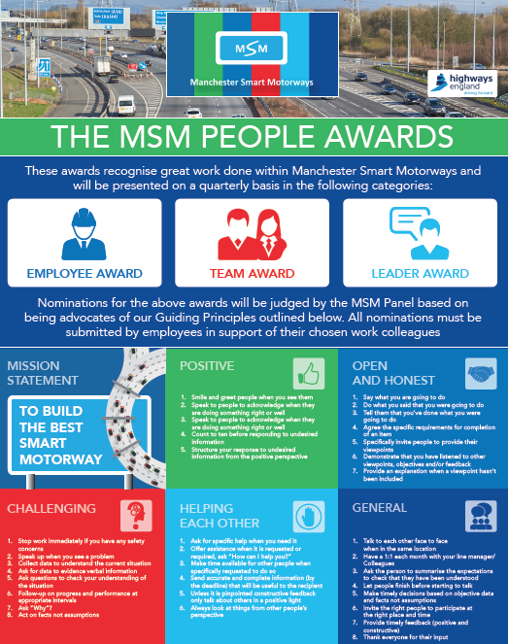  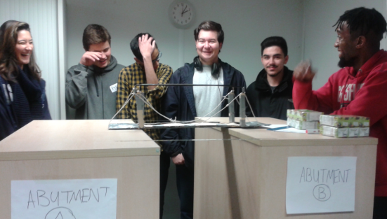
What have you done to encourage employees and suppliers to be better benefactors to local communities, the environment and the industry’s image?  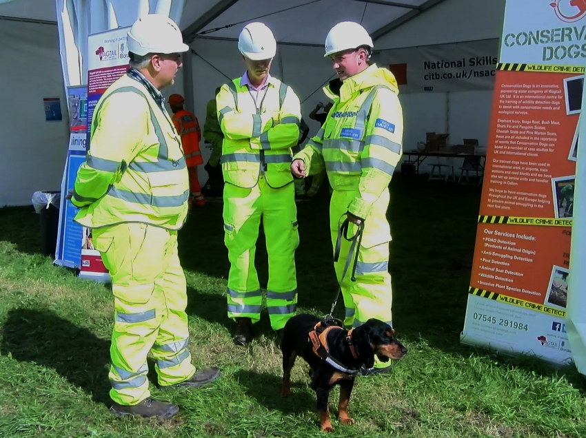  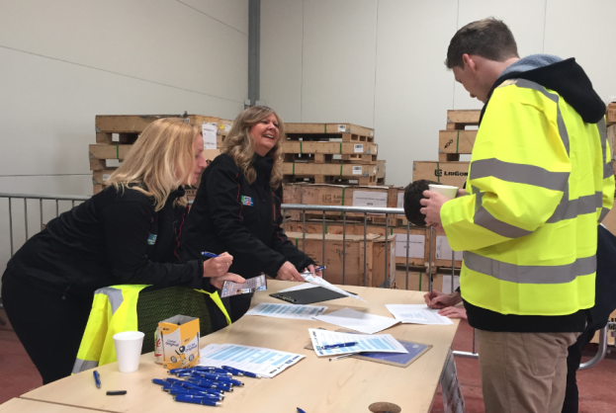  (maximum 250 words) | MSM has developed several industry leading initiatives, including:  - The introduction of a safety stand down event called Aiming for Zero in 2015 and 2016. Both events were attended by over 400 employees and key stakeholders. The event presented areas of risk that employees are regularly exposed to including working at height, plant interface and lifting. The day extended to a series of health related sessions focusing on stress awareness, cholesterol and stopping smoking and also showcased the use of conservation dogs on the project.This initiative is a first of its kind to be trailed in the highways sector and provides trained dogs to detect protected species such as bats and great crested newts.  “The approach that MSM has taken in regard to Aiming for Zero is industry leading. Combining a range of health, safety and wellbeing talks, demonstrations and information, the stand-down day reached a large group and encouraged continued engagement regarding training and health beyond the event.” Eddie Noonan, Highways England Health and Safety Director.  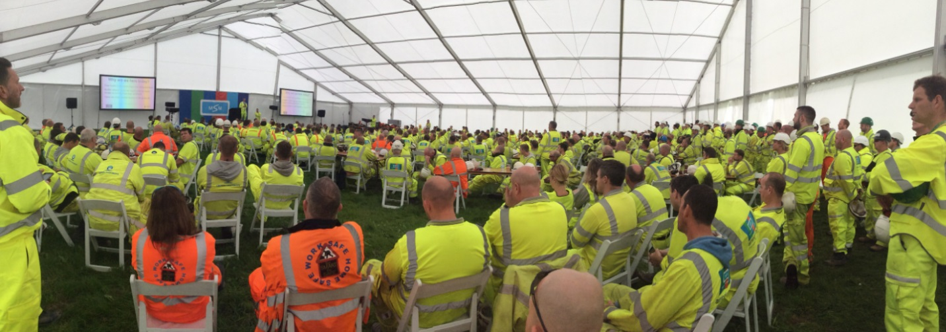  - Following a careers day hosted by Highway England, MSM and Flannery Plant Hire, six new roles have been established, including 3 apprenticeships, and a further 14 attendees selected for interview for future positions. The event was aimed at encouraging young learners into the construction industry. Individuals were given the opportunity to take part in machine operating challenges and trial a state of the art machinery simulator. The initiative is a first for Highways and is being shared with several other projects to deliver nationwide.
How does equality and diversity play a part in your organisation’s development planning?  (maximum 250 words) | 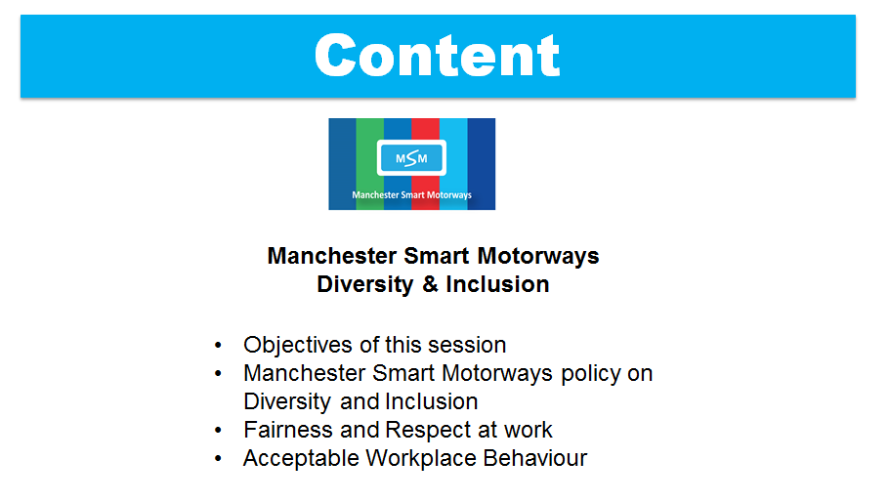  Introducing Quality and Diversity has been an integral part in MSMs employee development strategy and the Highways England National Major Projects Framework. MSM fully comply with all equality legislation and have created a specific policy to acknowledge that all employees must work together to create an environment where colleagues are treated fairly and equally. MSM welcome different ways of thinking, encourage innovation and aim to create a culture where everyone feels that they are able to raise new ideas. MSM recognises that its customers, joint venture partners and supply chain will benefit from having a diverse employee base that reflects the communities in which they work and is inclusive, flexible and responsive.  MSM has delivered the training in-house following a one day training course with material provided by the National Centre for Diversity. The training has reinforced acceptable workplace behaviours, creating an excellent culture of equality on the project.  “On a construction site, there’s always been an element of banter that can sometimes be taken too far. Employee actions and behaviours can lead to bullying in the workplace, sometimes without the individual in question even realising that they are doing anything wrong. When something is said in jest it can be taken out of context, upsetting the other person. The MSM Quality and Diversity training sets out clear guidelines that certain word and actions are not acceptable in a modern working environment.” Louise Pavitt, MSM Deputy Director.  Training has been rolled out to all members of staff employed by MSM.
Which elements of your development strategy do you monitor and what are your results?  (maximum 250 words) | MSM has been awarded National Skills Academy status through the Construction Industry Training Board (CITB), which has allowed the project to:  - Invest in a National Skills Coordinator  - Promote professional affiliation through organisations including ICE and CIHT; developing graduates, apprentices and emerging professionals throughout the project  - Improve the prospects of people through programme wide opportunities and skills training, delivering NVQ qualifications, short courses, individual skills profiles and a continued professional development strategy  - Produce a fully comprehensive community needs plan that has delivered several projects to the wider community including local homeless charity Salford, Loaves and Fishes  - Delivering a number of safety presentations to both primary and secondary schools located along the route, highlighting the importance of motorway construction and safety and the role of women in engineering  - Create employment opportunities for the unemployed and offenders  - Invest in training, development and apprenticeships for the low-skilled  - The project continues commit to support the delivery of training throughout the supply chain and all key performance indicator (KPIs) targets have been set to include the supply chain.  To date, MSM has hit over and above all of its KPIs and has raised over £16,000 for the local community through various fund raising events.
  National Skills Academy | Annual Target | KPI Year 1
  Case Studies Completed | 4 | 5
  Work Experience – other pathways | 8 | 7
  Work Experience - Students in Education (School or College) | 6 | 7
  Graduates Recruited | 4 | 8
  Apprentice Starts | 12 | 14
  Apprentice Completions | 8 | 2
  Jobs Created on Construction Projects | 20 | 47
  Construction Curriculum Support Activities (visits) | 100 | 350
  Curriculum Support Activities | 5 | 26
  NVQ starts for subcontractors | 25 | 27
  NVQ completions for subcontractors | 15 | 40
  Training Plans for subcontractors | 4 | 14
  Supervisor training for subcontractors | 15 | 18
  Leadership and Management training for subcontractors | 8 | 15
  Advanced Health and safety training for subcontractors. | 8 | 55
  Education Provider Agreements | 6 | 12
  Individual Skills Profile | 12 | 34
  Business Skills Diagnosis Support and Advice for subcontractors | 12 | 3
  HE Paid work placements - under/graduates | 5 | 6
  Day release - professional trainees | 3 | 3
  Site visits - higher education | 4 | 6
  Research Opportunity | 2 | 2
  HEI industry interaction | 3 | 4
  Ambassadors training - professional | 2 | 4
  Ambassadors training - Craft | 2 | 0
  Professional Development | 2 | 10
  Schools Activities (resource days) | 50 | 230
  Site visits - schools | 12 | 6
  Companies involved in local employment and training projects | 3 | 6
  Subcontractors with an equality policy and action plan | 2 | 2
  Work based recorders identified | 4 | 0
  Trainers Identified | 3 | 2
  Assessors trained(registered) | 2 | 2
  H&S test leading to competence cards for main contractors team | 12 | 10
  NVQ starts for main contractor employees | 12 | 1
  NVQ completions for main contractor employees | 10 | 1
  H&S test leading to competence cards for subcontractors | 6 | 44
  Supervisor Training for Main Contractors | 2 | 12
  Leadership and Management training for subcontractors | 8 | 24
  Advanced Health and Safety training for main contractors team | 2 | 10
  Accredited Training for Main Contractor | 50 | 88
  Short courses for main contractor's team | 6 | 18
  Professional Membership - CIOB/ICE/RICS | 3 | 11
  CPD Sessions | 10 | 33
What makes this submission a winning entry? Why do you think this work stands out from the crowd and how do you suggest we share this with the industry?  (maximum 500 words) | The greatest challenge facing MSM, in terms of people development, has been to improve the lives of individuals in inner city areas of Manchester. Through the Skills Coordinator’s expertise and ongoing collaboration with sub-contractors, local educational establishments, talent search groups and other key stakeholders, the project has given individuals, some from challenging backgrounds, the opportunity to gain work experience, return to work, gain an advanced qualification and develop their ongoing training.  The project has developed a long term relationship with Manchester’s only 24 hour emergency refuge centre for the homeless, helping to coordinate the storage and distribution of their annual harvest, raising over £15,000 for charity.  Above all, MSM has transformed the lives of two individuals with challenging backgrounds, giving them the opportunity of employment that they weren’t able to get elsewhere.  Case Study 1 – David Sighe  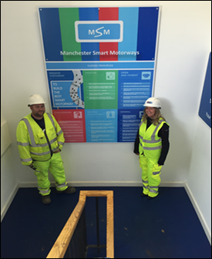  Through a unique collaboration with Salford Job Centre and Salford College, MSM has secured the full time work placement of long term unemployed local resident David Sighe. David had been out of work for over two years. He had applied for hundreds of jobs through the Government’s Back to Work scheme and was becoming increasingly frustrated when organisations were rejecting his applications and dismissing him for interview. David lost his confidence, which was having a major impact on his ability to look after his family financially. While David’s job search continued, MSM had been forging a special relationship with the local Job Centre, giving unemployed clients the opportunity to experience work on a construction site for the first time. The MSM Skills Coordinator met David and, following interview, knew straight away that he would be suitable to attend work experience. He was integrated onto site and given a permanent position within two weeks.  Case Study 2 - Robert Brown*  MSM has secured an apprenticeship for ex-offender Robert Jones. Robert had been serving a prison sentence and, due to good behaviour, been offered day release to gain work experience. Robert has shown outstanding resilience and determination, impressing employees at MSM. As a result, Robert has been offered a full time apprenticeship with Flannery’s Plant Hire, starting in April 2017. The process to sign off apprenticeships for ex-offenders is long and complex and has required negotiation, communication and trust from all parties involved.  In terms of sharing initiatives with industry, MSM has the advantage of being a large joint venture between 4 contractors, allowing access to several communication channels within each delivery partner including social media and press departments that deliver key messages to the wider field. MSM also shares initiatives on the Highways England Knowledge bank, which offers a platform to showcase best practice and continually raise the bar.  MSM has developed a unique community relations strategy, which has provided students, graduates, apprentices, minority groups and the long term unemployed with an opportunity to thrive in a working environment that offers career stability and development. The achievements of MSM will leave a lasting legacy in a local area that is socially challenging.  *Please note name have been changed for privacy reasons. Further verification can be provided if required.
Make sure you address the category criteria and ensure that the judges will understand:
Actions
What actions were taken to deliver outstanding outcomes?
Impact
What results were achieved and what evidence can you provide?
Lessons learned
What lessons have been learned through this work and how have they been shared?
The Constructing Excellence Awards ‘recognise the best and inspire the rest’.

What makes your submission special? We want to know if you are doing something that is new or different. Or if are you doing something that is common to the industry, but doing it better than anyone else. It could be how you manage a specific process or a wide ranging programme. It doesn’t need to be technologically cutting edge, but it does need to be exemplary.

Can you demonstrate real benefits? We want data. You needn’t submit all your information but we need to know that you have changed or achieved something through some measurable information. Did you do it cheaper, better or with increased satisfaction to your clients?
Is it honest? We are not looking for marketing information. We want real stories which give an honest summary of all the issues that you have overcome to deliver.

Check list:
Your entry should consist of:
  - Completed entry form – this is the only document used in the first stage of the judging process.
  - Logos for all key parties that should be recognised in connection with any award (original .eps files for print)
  - High resolution images (print quality). Logos and images are used for publicity purposes.
Contact: Peter McDermott or Angela Headlington on 0161 295 6861 or email
sobe-constructingexcellenceawards@salford.ac.uk
Submissions: Please email all submissions to sobe-constructingexcellenceawards@salford.ac.uk

